**Brewbean API Documentation**

**Brewbean APIs**

Version: v1.0.0

Update Date: June 9, 2021

**Overview**

Brewbean-backend allows users to develop applications that integrate with a customer instance of the brewbean coffee shop. The APIs are Rest services developed using Node.js and allow users/developers to retrieve and store data for the online coffee shop.

**Brewbean APIs**

Host the data of the Brewbean Coffee Shop website.

There are multiple endpoints/API actions available for this API, and this document describes them in detail:

Users API Action #1

|  |  |
| --- | --- |
| Functionality | Get the users of the Brewbean website application. |
| Base Path | https://warm-dusk-21815.herokuapp.com/ |
| Dependency | None |
| Endpoint URL / Resource | /api/v1/users |
| HTTP Methods | GET |
| Scope | This API allows a user to get the users account information that was supplied on the Brewbean website. |

Review the table below to understand this API’s 200 response parameters:

|  |  |  |
| --- | --- | --- |
| Output Param | Datatype | Description |
| isAdmin | Boolean | A boolean value that gives the user admin rights as a user in the system. |
| id | String | A unique string value that identifies each user. |
| email | String | A string value that represents the users email address in the system. |
| firstname | String | A string value that represents the users firstname in the system. |
| lastname | String | A string value that represents the users lastname in the system. |
| password | String | An encrypted string value that represents the users password in the system. |

Sample Response:

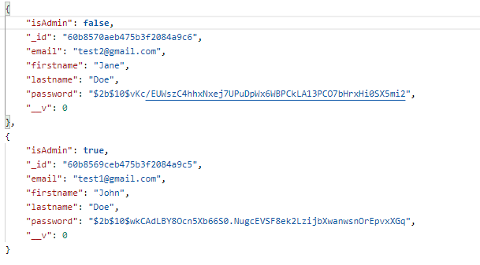

Users API Action #2

|  |  |
| --- | --- |
| Functionality | Get the current user based on userid from the system. |
| Base Path | https://warm-dusk-21815.herokuapp.com/ |
| Dependency | None |
| Endpoint URL / Resource | /api/v1/users/:id |
| HTTP Methods | GET |
| Scope | This API allows a user to get specific user account information that was supplied in the system. |

Review the table below to understand this API’s 200 response parameters:

|  |  |  |
| --- | --- | --- |
| Output Param | Datatype | Description |
| isAdmin | Boolean | A boolean value that gives the user admin rights as a user in the system. |
| id | String | A unique string value that identifies each user. |
| email | String | A string value that represents the users email address in the system. |
| firstname | String | A string value that represents the users firstname in the system. |
| lastname | String | A string value that represents the users lastname in the system. |
| password | String | The user’s password will be encrypted (bcrypt) before being stored in the database. |

Sample Response:

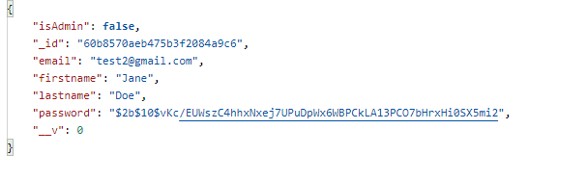

Review the table below to understand this API’s 404 response parameters:

|  |  |  |
| --- | --- | --- |
| Output Param | Datatype | Description |
| code | String | The error code. |
| message | String | Textual description of the problem. |

Sample Response:





Users API Action #3

|  |  |
| --- | --- |
| Functionality | Add the user to the system. |
| Base Path | https://warm-dusk-21815.herokuapp.com/ |
| Dependency | None |
| Endpoint URL / Resource | /api/v1/users/ |
| HTTP Methods | POST |
| Scope | This API allows a user’s information to be stored in a MongoDB database on the backend. |

Request Body Parameters for API Action #3

|  |  |  |  |
| --- | --- | --- | --- |
| Input Param | Datatype | REQ* | Description |
| email | String | Required | A valid email address for a user placing an order on the website. Must be a unique value. |
| firstname | String | Required | User’s firstname. Must be 3 or more characters in length. |
| lastname | String | Required | User’s lastname. Must be 3 or more characters in length. |
| password | String | Required | User’s password. Must be 5 or more characters in length. |
| isAdmin | Boolean | Optional | Set user’s rights to Administrator. Default value is false. |

Sample Request:

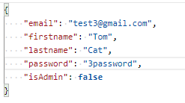

Review the table below to understand this API’s 200 response parameters:

|  |  |  |
| --- | --- | --- |
| Output Param | Datatype | Description |
| id | Boolean | A boolean value that gives the user admin rights as a user in the system. |
| email | String | A unique string value that identifies each user. |
| firstname | String | A string value that represents the users firstname. |
| lastname | String | A string value that represents the users lastname. |
| isAdmin | String | An encrypted string value that represents the users password. |
| x-auth-token | String | Authentication token passed back in the header if valid post is made. User needs to use this token to authenticate when placing an order. It also contains the value of isAdmin to verify if the user is an administrator. |

Sample Response:

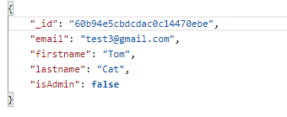



Review the table below to understand this API’s 400 response parameters:

|  |  |  |
| --- | --- | --- |
| Output Param | Datatype | Description |
| code | String | The error code. |
| message | String | Textual description of the problem. |

Sample Response:





Users API Action #4

|  |  |
| --- | --- |
| Functionality | Update the user’s account information in the system. |
| Base Path | https://warm-dusk-21815.herokuapp.com/ |
| Dependency | None |
| Endpoint URL / Resource | /api/v1/users/:id |
| HTTP Methods | PUT |
| Scope | This API allows a user’s information to be updated in a MongoDB database on the backend. |

Request Body Parameters for API Action #4

|  |  |  |  |
| --- | --- | --- | --- |
| Input Param | Datatype | REQ* | Description |
| email | String | Required | Update email address for a user placing an order on the website. Must be a unique value. Enter current value if value will not change. |
| firstname | String | Required | Update user’s firstname. Must be 3 or more characters in length. Enter current value if value will not change. |
| lastname | String | Required | Update user’s lastname. Must be 3 or more characters in length. Enter current value if value will not change. |
| password | String | Required | User’s password. Must be 5 or more characters in length. Enter current value if value will not change. |
| isAdmin | Boolean | Optional | Update user Administrator rights. |

Sample Request:

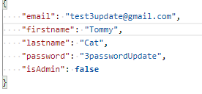

Review the table below to understand this API’s 200 response parameters:

|  |  |  |
| --- | --- | --- |
| Output Param | Datatype | Description |
| isAdmin | Boolean | A boolean value that gives the user admin rights as a user in the system. |
| id | String | A unique string value that identifies each user. |
| email | String | A string value that represents the user’s updated email. |
| firstname | String | A string value that represents the user’s updated firstname |
| lastname | String | A string value that represents the user’s updated lastname. |
| password | String | A string value that represents the user’s updated password. |

Sample Response:

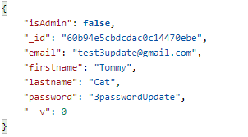

Review the table below to understand this API’s 400 response parameters:

|  |  |  |
| --- | --- | --- |
| Output Param | Datatype | Description |
| code | String | The error code. |
| message | String | Textual description of the problem. |

Sample Response:





Or



Review the table below to understand this API’s 404 response parameters:

|  |  |  |
| --- | --- | --- |
| Output Param | Datatype | Description |
| code | String | The error code. |
| message | String | Textual description of the problem. |

Sample Response:





Review the table below to understand this API’s 401 response parameters:

|  |  |  |
| --- | --- | --- |
| Output Param | Datatype | Description |
| code | String | The error code. |
| message | String | Textual description of the problem. |

Sample Response:





Users API Action #5

|  |  |
| --- | --- |
| Functionality | Delete the user from the system. |
| Base Path | https://warm-dusk-21815.herokuapp.com/ |
| Dependency | None |
| Endpoint URL / Resource | /api/v1/users/:id |
| HTTP Methods | DELETE |
| Scope | This API allows a user to be deleted from the MongoDB database on the backend. |

Review the table below to understand this API’s 200 response parameters:

|  |  |  |
| --- | --- | --- |
| Output Param | Datatype | Description |
| isAdmin | Boolean | A boolean value that gives the user admin rights as a user in the system. |
| id | String | A unique string value that identifies the user that’s deleted from the system. |
| email | String | A string value that represents the users email address that will be deleted. |
| firstname | String | A string value that represents the users firstname that will be deleted. |
| lastname | String | A string value that represents the users lastname that will be deleted. |
| password | String | The user’s password that will be deleted from the system. |

Sample Response:

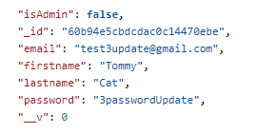

Review the table below to understand this API’s 401 response parameters:

|  |  |  |
| --- | --- | --- |
| Output Param | Datatype | Description |
| code | String | The error code. |
| message | String | Textual description of the problem. |

Sample Response:





Review the table below to understand this API’s 403 response parameters:

|  |  |  |
| --- | --- | --- |
| Output Param | Datatype | Description |
| code | String | The error code. |
| message | String | Textual description of the problem. |

Sample Response:





Review the table below to understand this API’s 404 response parameters:

|  |  |  |
| --- | --- | --- |
| Output Param | Datatype | Description |
| code | String | The error code. |
| message | String | Textual description of the problem. |





Coffee API Action #1

|  |  |
| --- | --- |
| Functionality | Get the coffee items from the system. |
| Base Path | https://warm-dusk-21815.herokuapp.com/ |
| Dependency | None |
| Endpoint URL / Resource | /api/v1/coffee |
| HTTP Methods | GET |
| Scope | This API allows a user to retrieve all available coffee items from the system stored in a MongoDB database. |

Review the table below to understand this API’s 200 response parameters:

|  |  |  |
| --- | --- | --- |
| Output Param | Datatype | Description |
| coffee | Array | A list of available coffees in the system. |
| creamer | Array | A list of available coffee creamers in the system. |
| topping | Array | A list of available coffee toppings in the system. |
| syrup | Array | A list of available coffee syrups in the system. |
| sweetener | Array | A list of available coffee sweeteners in the system. |
| price | Number | The price of the coffee in the system. |
| id | String | Unique id generated from MongoDB database. |

Sample Response:

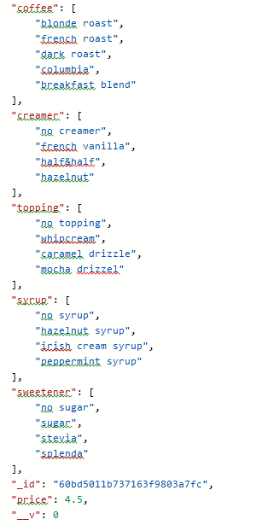

Coffee API Action #2

|  |  |
| --- | --- |
| Functionality | Get the current coffee items based on id. |
| Base Path | https://warm-dusk-21815.herokuapp.com/ |
| Dependency | None |
| Endpoint URL / Resource | /api/v1/coffee/:id |
| HTTP Methods | GET |
| Scope | This API allows a user to get specific coffee items stored in the system. |

Review the table below to understand this API’s 200 response parameters:

|  |  |  |
| --- | --- | --- |
| Output Param | Datatype | Description |
| coffee | Array | An list of available coffees in the system. |
| creamer | Array | A list of available coffee creamers in the system. |
| topping | Array | A list of available coffee toppings in the system. |
| syrup | Array | A list of available coffee syrups in the system. |
| sweetener | Array | A list of available coffee sweeteners in the system. |
| price | Number | The price of the coffee in the system. |
| id | String | Unique Id generated from MongoDB database. |

Sample Response:



Review the table below to understand this API’s 404 response parameters:

|  |  |  |
| --- | --- | --- |
| Output Param | Datatype | Description |
| code | String | The error code. |
| message | String | Textual description of the problem. |

Sample Response:





Coffee API Action #3

|  |  |
| --- | --- |
| Functionality | Add the coffee items to the system. |
| Base Path | https://warm-dusk-21815.herokuapp.com/ |
| Dependency | None |
| Endpoint URL / Resource | /api/v1/coffee/ |
| HTTP Methods | POST |
| Scope | This API allows coffee items to be stored in a MongoDB database on the backend.  This API also requires an x-auth-token (JWT -JSON Webtoken) to be supplied in the request header. |

Request Body Parameters for API Action #3

|  |  |  |  |
| --- | --- | --- | --- |
| Input Param | Datatype | REQ* | Description |
| coffee | Array | Required | An array of at least three coffee types. |
| creamer | Array | Required | An array of at least three creamers for the coffee types. |
| topping | Array | Required | An array of at least three toppings for the coffee types. |
| syrup | Array | Required | An array of at least three syrups for the coffee types. |
| sweetener | Array | Required | An array of at least three sweeteners for the coffee types. |
| price | Price | Required | The total price of the coffee including its additional items (creamer, topping, etc.) |

Sample Request:

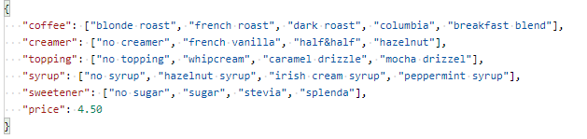

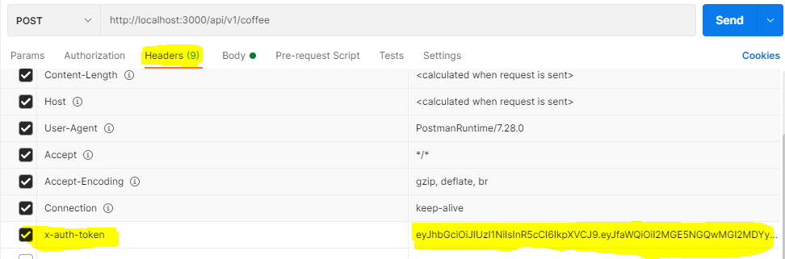

Review the table below to understand this API’s 200 response parameters:

|  |  |  |
| --- | --- | --- |
| Output Param | Datatype | Description |
| coffee | Array | An list of available coffees in the system. |
| creamer | Array | A list of available coffee creamers in the system. |
| topping | Array | A list of available coffee toppings in the system. |
| syrup | Array | A list of available coffee syrups in the system. |
| sweetener | Array | A list of available coffee sweeteners in the system. |
| price | Number | The price of the coffee in the system. |
| id | String | Unique id generated from MongoDb database. |

Sample Response:



Review the table below to understand this API’s 400 response parameters:

|  |  |  |
| --- | --- | --- |
| Output Param | Datatype | Description |
| code | String | The error code. |
| message | String | Textual description of the problem. |

Sample Response:





Review the table below to understand this API’s 401 response parameters:

|  |  |  |
| --- | --- | --- |
| Output Param | Datatype | Description |
| code | String | The error code. |
| message | String | Textual description of the problem. |

Sample Response:





Coffee API Action #4

|  |  |
| --- | --- |
| Functionality | Update the coffee items in the system. |
| Base Path | https://warm-dusk-21815.herokuapp.com/ |
| Dependency | None |
| Endpoint URL / Resource | /api/v1/coffee/:id |
| HTTP Methods | PUT |
| Scope | This API allows a coffee item to be updated in a MongoDB database on the backend.  This API also requires an x-auth-token (JWT -JSON Webtoken) to be supplied in the request header. |

Request Body Parameters for API Action #4

|  |  |  |  |
| --- | --- | --- | --- |
| Input Param | Datatype | REQ* | Description |
| coffee | Array | Required | Update coffee. Must be 3 or more elements in the array and a unique value. Enter current values if values will not change. |
| creamer | Array | Required | Update creamer. Must be 3 or more elements in the array. Enter current values if values will not change. |
| topping | Array | Required | Update topping. Must be 3 or more elements in the array. Enter current values if values will not change. |
| syrup | Array | Required | Update syrup. Must be 3 or more elements in the array. Enter current values if values will not change. |
| sweetener | Array | Required | Update sweetener. Must be 3 or more elements in the array. Enter current values if values will not change. |
| price | Number | Required | Update price. Enter current value if value will not change. |

Sample Request:

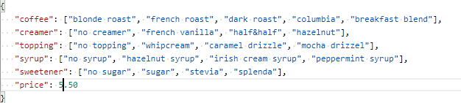

Review the table below to understand this API’s 200 response parameters:

|  |  |  |
| --- | --- | --- |
| Output Param | Datatype | Description |
| coffee | Array | An list of available coffees in the system. |
| creamer | Array | A list of available coffee creamers in the system. |
| topping | Array | A list of available coffee toppings in the system. |
| syrup | Array | A list of available coffee syrups in the system. |
| sweetener | Array | A list of available coffee sweeteners in the system. |
| price | Number | The price of the coffee in the system. |
| id | String | Unique id generated from MongoDb database. |

Sample Response:

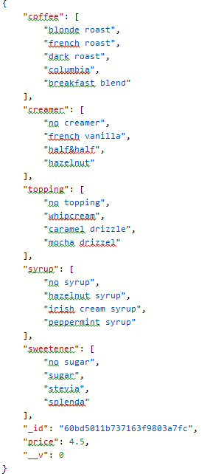

Review the table below to understand this API’s 400 response parameters:

|  |  |  |
| --- | --- | --- |
| Output Param | Datatype | Description |
| code | String | The error code. |
| message | String | Textual description of the problem. |

Sample Response:





Or



Review the table below to understand this API’s 401 response parameters:

|  |  |  |
| --- | --- | --- |
| Output Param | Datatype | Description |
| code | String | The error code. |
| message | String | Textual description of the problem. |

Sample Response:





Review the table below to understand this API’s 404 response parameters:

|  |  |  |
| --- | --- | --- |
| Output Param | Datatype | Description |
| code | String | The error code. |
| message | String | Textual description of the problem. |

Sample Response:





Coffee API Action #5

|  |  |
| --- | --- |
| Functionality | Delete the coffee items from the system. |
| Base Path | https://warm-dusk-21815.herokuapp.com/ |
| Dependency | None |
| Endpoint URL / Resource | /api/v1/coffee/:id |
| HTTP Methods | DELETE |
| Scope | This API allows coffee items to be deleted from the MongoDB database on the backend.  This API also requires an x-auth-token (JWT -JSON Webtoken) to be supplied in the request header. |

Review the table below to understand this API’s 200 response parameters:

|  |  |  |
| --- | --- | --- |
| Output Param | Datatype | Description |
| coffee | Array | The array of coffees that were deleted from the system. |
| creamer | Array | The array of creamers that were deleted from the system. |
| topping | Array | The array of toppings that were deleted from the system. |
| syrup | Array | The array of syrups that were deleted from the system. |
| sweetener | Array | The array of sweeteners that were deleted from the system. |
| price | Number | The coffee price that was deleted from the system. |
| id | String | The coffee id deleted from the system. |

Sample Response:



Review the table below to understand this API’s 401 response parameters:

|  |  |  |
| --- | --- | --- |
| Output Param | Datatype | Description |
| code | String | The error code. |
| message | String | Textual description of the problem. |

Sample Response:





Review the table below to understand this API’s 403 response parameters:

|  |  |  |
| --- | --- | --- |
| Output Param | Datatype | Description |
| code | String | The error code. |
| message | String | Textual description of the problem. |

Sample Response:





Review the table below to understand this API’s 404 response parameters:

|  |  |  |
| --- | --- | --- |
| Output Param | Datatype | Description |
| code | String | The error code. |
| message | String | Textual description of the problem. |





Orders API Action #1

|  |  |
| --- | --- |
| Functionality | Get the current orders in the system. |
| Base Path | https://warm-dusk-21815.herokuapp.com/ |
| Dependency | None |
| Endpoint URL / Resource | /api/v1/orders |
| HTTP Methods | GET |
| Scope | This API retrieves all orders in the system. |

Review the table below to understand this API’s 200 response parameters:

|  |  |  |
| --- | --- | --- |
| Output Param | Datatype | Description |
| id | String | Unique id generated from MongoDB database for order. |
| coffee | String | The coffee ordered. |
| creamer | String | The creamer ordered. |
| topping | String | The topping ordered. |
| syrup | String | The syrup ordered. |
| sweetener | String | The sweetener ordered. |
| price | Number | The price of the coffee ordered. |
| quantity | Number | The amount of coffees ordered. |
| subtotal | Number | The subtotal of the order (price * quantity) |
| User | String | The user’s id that placed the order. |

Sample Response:

{

        "_id": "60c00c74ef30535dd47f1477",

        "coffee": "columbia",

        "creamer": "french vanilla",

        "topping": "no topping",

        "syrup": "no syrup",

        "sweetener": "stevia",

        "price": 4.5,

        "quantity": 2,

        "subTotal": 9,

        "user": "60bfdd7f4550785318a0d691",

        "__v": 0

    },

    {

        "_id": "60c016ba25fcc9600cc060aa",

        "coffee": "dark roast",

        "creamer": "half & half",

        "topping": "no topping",

        "syrup": "no syrup",

        "sweetener": "sugar",

        "price": 4.5,

        "quantity": 1,

        "subTotal": 4.5,

        "user": "60bfde314550785318a0d692",

        "__v": 0

    }

Orders API Action #2

|  |  |
| --- | --- |
| Functionality | Get the order based on order id. |
| Base Path | https://warm-dusk-21815.herokuapp.com/ |
| Dependency | None |
| Endpoint URL / Resource | /api/v1/orders/:id |
| HTTP Methods | GET |
| Scope | This API allows a user to get specific order from the system based on order id. |

Review the table below to understand this API’s 200 response parameters:

|  |  |  |
| --- | --- | --- |
| Output Param | Datatype | Description |
| id | String | Id used in endpoint to return the order based on this id. |
| coffee | String | Coffee ordered based on order id. |
| creamer | String | Creamer ordered based on order id. |
| topping | String | Topping ordered based on order id. |
| syrup | String | Syrup ordered based on order id. |
| sweetener | String | Sweetener ordered based on order id. |
| price | Number | The price of the coffee ordered. |
| quantity | Number | Amount of coffees ordered. |
| subtotal | Number | The subtotal of the order (price * quantity). |
| user | String | The user’s id that placed the order. |

Sample Response:

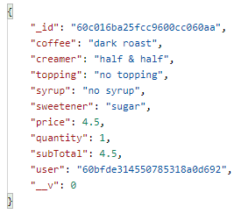

Review the table below to understand this API’s 404 response parameters:

|  |  |  |
| --- | --- | --- |
| Output Param | Datatype | Description |
| code | String | The error code. |
| message | String | Textual description of the problem. |

Sample Response:





Orders API Action #3

|  |  |
| --- | --- |
| Functionality | Get the user’s order based on user id. |
| Base Path | https://warm-dusk-21815.herokuapp.com/ |
| Dependency | None |
| Endpoint URL / Resource | /api/v1/orders/getOrder |
| HTTP Methods | GET |
| Scope | This API allows a user to get specific order from the system based on the user’s id. |

Review the table below to understand this API’s 200 response parameters:

|  |  |  |
| --- | --- | --- |
| Output Param | Datatype | Description |
| id | String | Order id of the order placed. |
| coffee | String | Coffee ordered by user. |
| creamer | String | Creamer ordered by user. |
| topping | String | Topping ordered by user. |
| syrup | String | Syrup ordered by user. |
| sweetener | String | Sweetener ordered by user. |
| price | Number | The price of the coffee ordered. |
| quantity | Number | Amount of coffees ordered. |
| subtotal | Number | The subtotal of the order (price * quantity). |
| user | String | The user’s id that placed the order. |

Sample Response:



Review the table below to understand this API’s 404 response parameters:

|  |  |  |
| --- | --- | --- |
| Output Param | Datatype | Description |
| code | String | The error code. |
| message | String | Textual description of the problem. |

Sample Response:





Orders API Action #4

|  |  |
| --- | --- |
| Functionality | Add the order to the system. |
| Base Path | https://warm-dusk-21815.herokuapp.com/ |
| Dependency | None |
| Endpoint URL / Resource | /api/v1/orders/ |
| HTTP Methods | POST |
| Scope | This API allows order to be stored in a MongoDB database on the backend.  This API also requires an x-auth-token (JWT -JSON Webtoken) to be supplied in the request header. |

Request Body Parameters for API Action #4

|  |  |  |  |
| --- | --- | --- | --- |
| Input Param | Datatype | REQ* | Description |
| coffee | String | Required | A string of at least five characters. |
| creamer | String | Required | A string of at least five characters. |
| topping | String | Required | A string of at least five characters. |
| syrup | String | Required | A string of at least five characters. |
| sweetener | String | Required | A string of at least five characters. |
| price | Price | Required | A number representing the price of the coffee |
| quantity | Number | Required | A number representing the amount of coffees ordered. |
| user | String | Required | User id from user schema that the order is for. |

Sample Request:

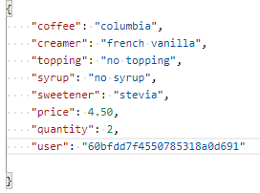



Review the table below to understand this API’s 200 response parameters:

|  |  |  |
| --- | --- | --- |
| Output Param | Datatype | Description |
| Id | String | Unique id generated from MongoDb database for the order. |
| coffee | String | Name of coffee ordered. |
| creamer | String | Name of creamer ordered. |
| topping | String | Name of topping ordered. |
| syrup | String | Name of syrup ordered. |
| sweetener | String | Name of sweetener ordered. |
| price | Number | The price of the coffee ordered. |
| quantity | Number | The quantity of the coffee ordered. |
| subtotal | Number | Subtotal of ordered coffee. |
| user | String | Id of the user the order is for. |

Sample Response:

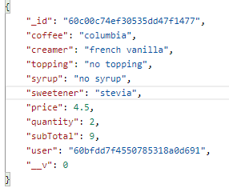

Review the table below to understand this API’s 400 response parameters:

|  |  |  |
| --- | --- | --- |
| Output Param | Datatype | Description |
| code | String | The error code. |
| message | String | Textual description of the problem. |

Sample Response:





Review the table below to understand this API’s 400 response parameters:

|  |  |  |
| --- | --- | --- |
| Output Param | Datatype | Description |
| code | String | The error code. |
| message | String | Textual description of the problem. |

Sample Response:





Review the table below to understand this API’s 401 response parameters:

|  |  |  |
| --- | --- | --- |
| Output Param | Datatype | Description |
| code | String | The error code. |
| message | String | Textual description of the problem. |

Sample Response:





Orders API Action #5

|  |  |
| --- | --- |
| Functionality | Update the order in the system. |
| Base Path | https://warm-dusk-21815.herokuapp.com/ |
| Dependency | None |
| Endpoint URL / Resource | /api/v1/orders/:id |
| HTTP Methods | PUT |
| Scope | This API allows an order be updated in a MongoDB database on the backend.  This API also requires an x-auth-token (JWT -JSON Webtoken) to be supplied in the request header. |

Request Body Parameters for API Action #5

|  |  |  |  |
| --- | --- | --- | --- |
| Input Param | Datatype | REQ* | Description |
| coffee | String | Required | Update coffee. Must be 5 or more characters long. Enter current value if value will not change. |
| creamer | String | Required | Update creamer. Must be 5 or more characters long. Enter current value if value will not change. |
| topping | String | Required | Update topping. Must be 5 or more characters long. Enter current value if value will not change. |
| syrup | String | Required | Update syrup. Must be 5 or more characters long. Enter current value if value will not change. |
| sweetener | String | Required | Update sweetener. Must be 5 or more characters long. Enter current value if value will not change. |
| price | Number | Required | Update price. Enter current value if value will not change. |
| User | String | Required | Update user id. Enter current value if value will not change. |

Sample Request:

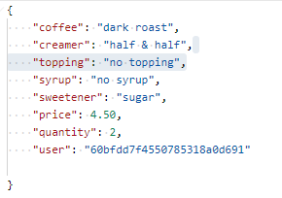

Review the table below to understand this API’s 200 response parameters:

|  |  |  |
| --- | --- | --- |
| Output Param | Datatype | Description |
| id | String | Id of order that’s been updated. |
| coffee | Array | Coffee name that may have been updated. |
| creamer | Array | Creamer name that may have been updated. |
| topping | Array | Topping name that may have been updated. |
| syrup | Array | Syrup name that may have been updated. |
| sweetener | Array | Sweetener name that may have been updated. |
| price | Number | Price of order that may have been updated. |
| quantity | Number | Quantity of coffees that may have been updated. |
| subtotal | Number | Subtotal of updated order. |
| user | String | User id that may have been updated in the order. |

Sample Response:

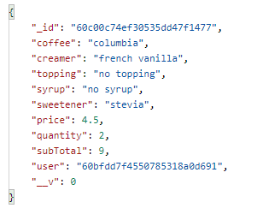

Review the table below to understand this API’s 400 response parameters:

|  |  |  |
| --- | --- | --- |
| Output Param | Datatype | Description |
| code | String | The error code. |
| message | String | Textual description of the problem. |

Sample Response:





Or



Review the table below to understand this API’s 404 response parameters:

|  |  |  |
| --- | --- | --- |
| Output Param | Datatype | Description |
| code | String | The error code. |
| message | String | Textual description of the problem. |

Sample Response:





Orders API Action #6

|  |  |
| --- | --- |
| Functionality | Delete the order from the system. |
| Base Path | https://warm-dusk-21815.herokuapp.com/ |
| Dependency | None |
| Endpoint URL / Resource | /api/v1/orders/:id |
| HTTP Methods | DELETE |
| Scope | This API allows orders to be deleted from the MongoDB database on the backend.  This API also requires an x-auth-token (JWT -JSON Webtoken) to be supplied in the request header. |

Review the table below to understand this API’s 200 response parameters:

|  |  |  |
| --- | --- | --- |
| Output Param | Datatype | Description |
| id | String |  |
| coffee | Array | The array of coffees that were deleted from the system. |
| creamer | Array | The array of creamers that were deleted from the system. |
| topping | Array | The array of toppings that were deleted from the system. |
| syrup | Array | The array of syrups that were deleted from the system. |
| sweetener | Array | The array of sweeteners that were deleted from the system. |
| price | Number | The coffee price that was deleted from the system. |
| quantity | Number | The coffee id deleted from the system. |
| subtotal | Number |  |
| user | String |  |

Sample Response:

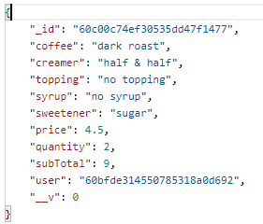

Review the table below to understand this API’s 401 response parameters:

|  |  |  |
| --- | --- | --- |
| Output Param | Datatype | Description |
| code | String | The error code. |
| message | String | Textual description of the problem. |

Sample Response:





Review the table below to understand this API’s 403 response parameters:

|  |  |  |
| --- | --- | --- |
| Output Param | Datatype | Description |
| code | String | The error code. |
| message | String | Textual description of the problem. |

Sample Response:





Review the table below to understand this API’s 404 response parameters:

|  |  |  |
| --- | --- | --- |
| Output Param | Datatype | Description |
| code | String | The error code. |
| message | String | Textual description of the problem. |



